EXP-14:

Aim: To Design Push Down Automata using simulator to accept the input string anb2n .

Diagram:

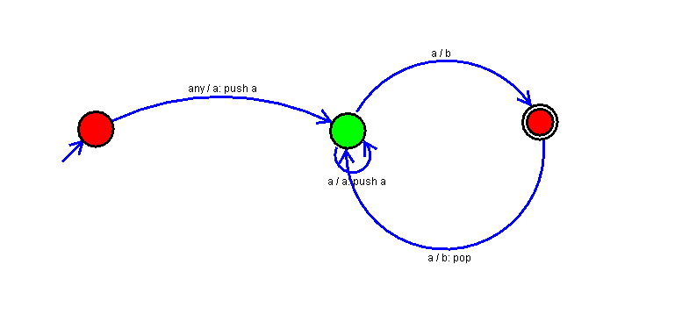

Result:

Successfully executed Push Down Automata using simulator to accept the input string anb2n .